O(N)

O(N^2)

O(2^N)

O(log N)

O(N log N)

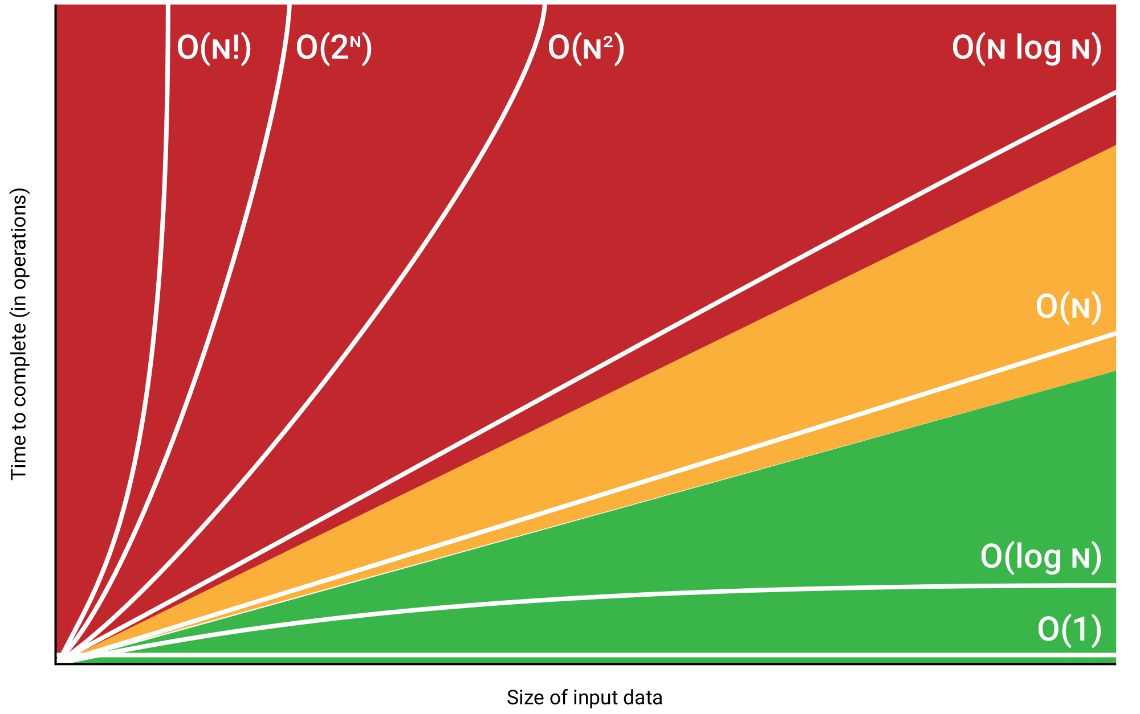

Do not use constants: O(2*N) is just O(N)

Do not use non-dominant terms: O(N^2 + N) is O(N^2)  
O(N + log N) is O(N)  
O(2^N + 500*N^500) is O(2^N)

**Multiply vs Add:**- Do this, then when we’re all done, do that: Add  
- Do this, for each time you do that: Multiply

**Amortized time:** Yeah, there’s a worst case, but it’s so rare, even if it happens, for so long it won’t happen again.